

Telpo customer service system user guide

**Telepower Communication Co., Ltd**

# Directory

1 Introduction 3

2 Function Description and precautions 4

2.1 . Ticket submission 4

2.2 . Ticket query 5

2.3 . FAQ download 9

# **Introduction**

Telpo Q&A platform,you can search or ask technical questions here.

Login link: https://www.telpo.vip:1351/

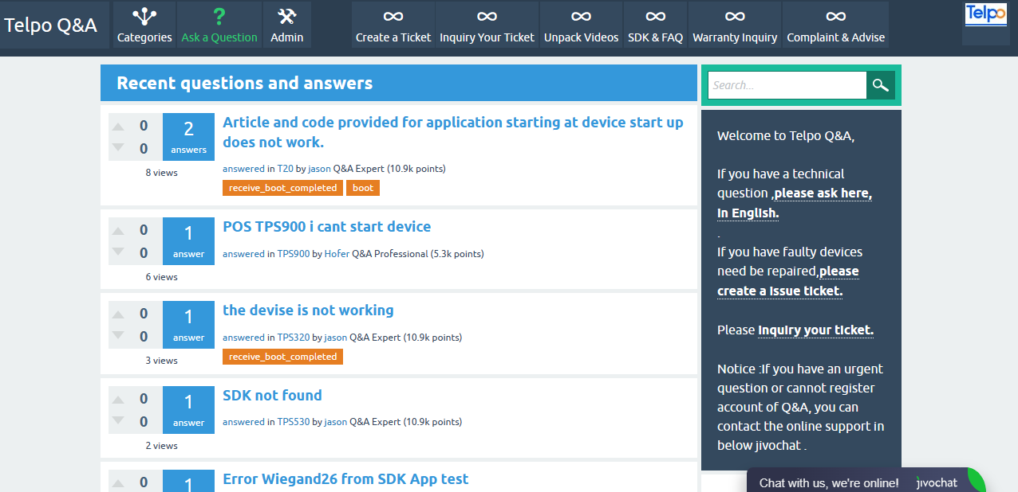

The following main modules are included:

1). Inquire and ask technical questions,Please register your account and log in.For urgent problems, please contact online customer service engineer at the lower right corner .

2). Product unpacking video

3). Failure declaration and inquiry ,If there is any quality problem of product, please submit the tickets and we will arrange engineers to follow up within 24 hours

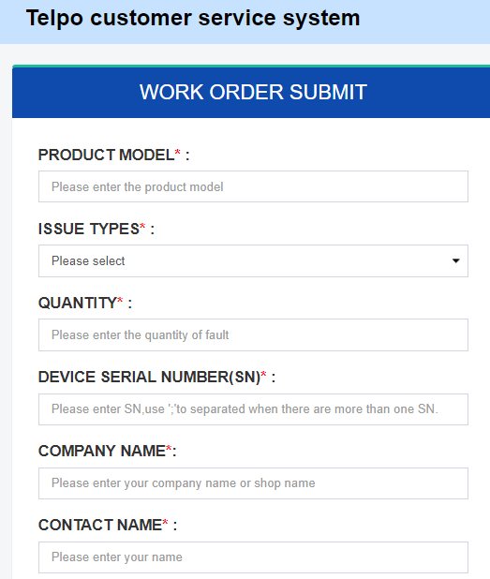

1. . Download of technical files

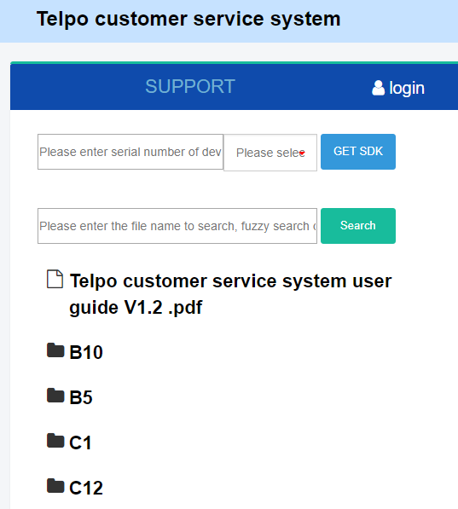

1. Warranty inquire

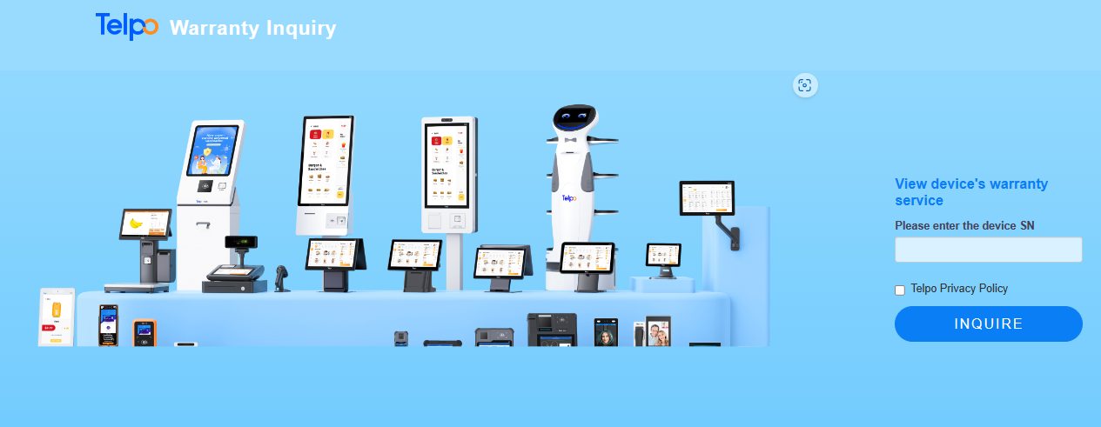

# **Function Description and precautions**

## . Ticket submission

If you encounter product quality problems or need technical support, you can submit work orders

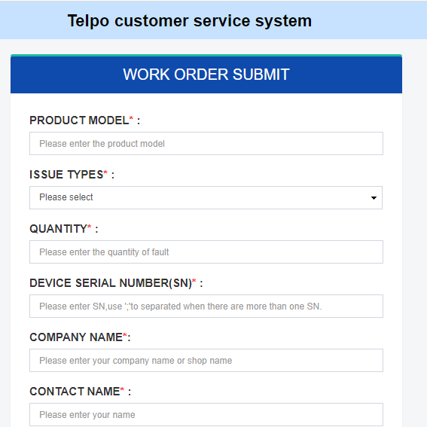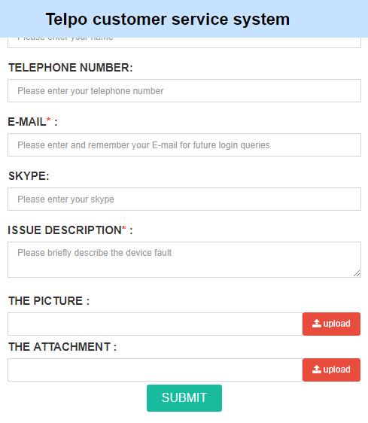

1. Note that you need to remember the email address you entered when submitting the work order, so that you can check the order later
2. Asterisks are mandatory
3. PRODUCT MODEL：It can be queried on the device label or from system Settings
4. ISSUE TYPES：Set this parameter based on the actual fault condition. For technical support, you can set others.
5. QUANTITY:Number of faults, please fill in "1" for technical support.
6. DEVICE SERIAL NUMBER(SN):it is important information ,It can be queried on the device label or from system Settings,Please be sure to fill in accurately
7. COMPANY NAME:please input your company name
8. CONTACT NAME:please input your name
9. TELEPHONE NUMBER:optional
10. E-MAIL* :it is important infomations .Please be sure to fill in accuratel,the email must same as Q&A login email,then you can get the ticket progress
11. SKYPE:optional,Please be sure to fill in accuratel.and we will contact with you
12. ISSUE DESCRIPTION* :Describe the symptom of the problem. How long does it take for the problem to occur? Can the problem be solved after restart? Are there hardware and software maintenance personnel?and so on
13. THE PICTURE& ATTACHMENT:Try to provide fault photos or videos for us to analyze as soon as possible

After input all the infomations ,please remember your email and click “submit”

## . Ticket query

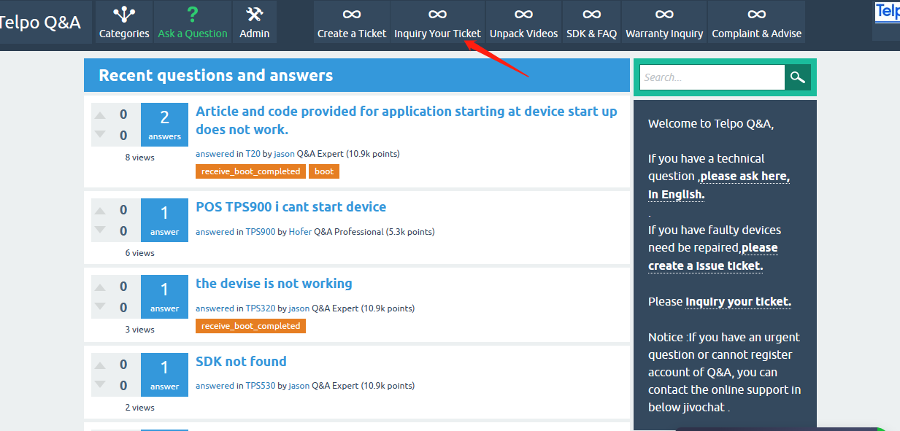

You can query the current tickets total and completion status.if you don’t forget the ticket No or Email ,please contact with telpo engineer.

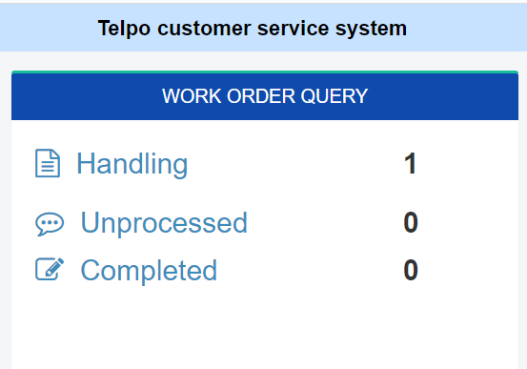

Please be aware of ongoing cases as Telpo engineers may initiate an online communication and you can also initiate a message to us. Once we receive a message, we will respond

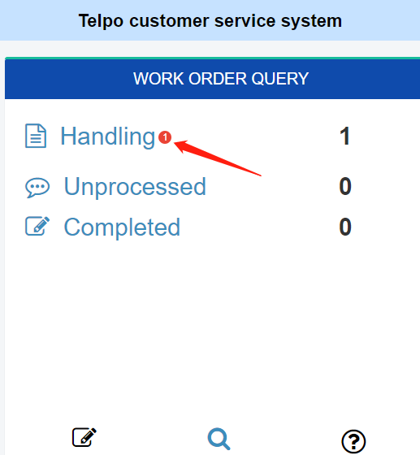

Please select “Task reply”to contact online .If you don't get a message, try refreshing the url

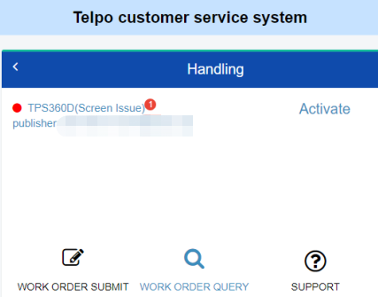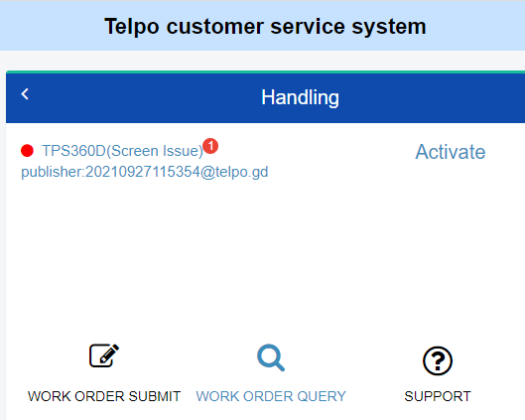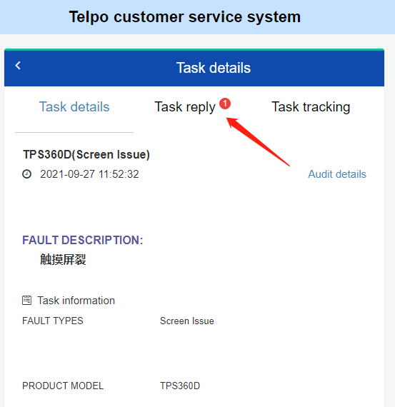

You can send your questions to Telpo engineers

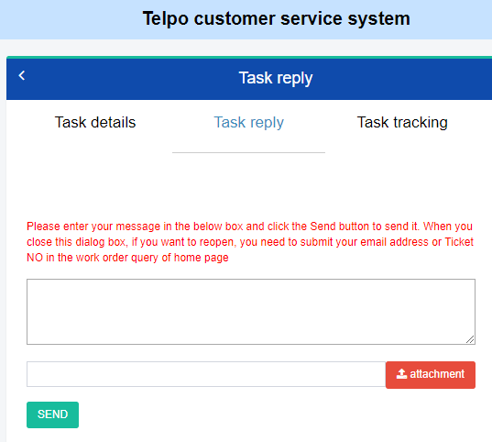

You can check the ticket details and process

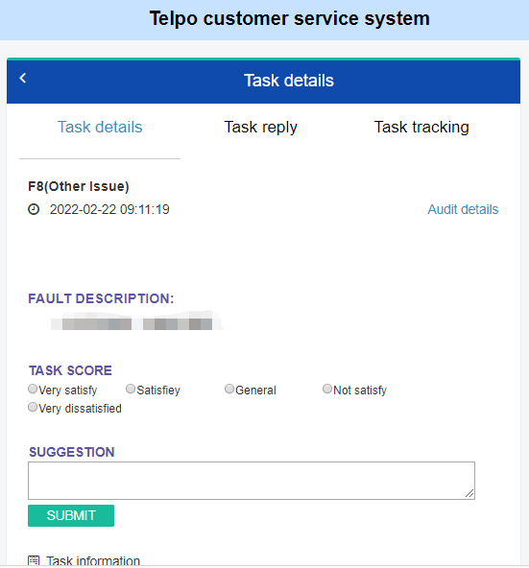

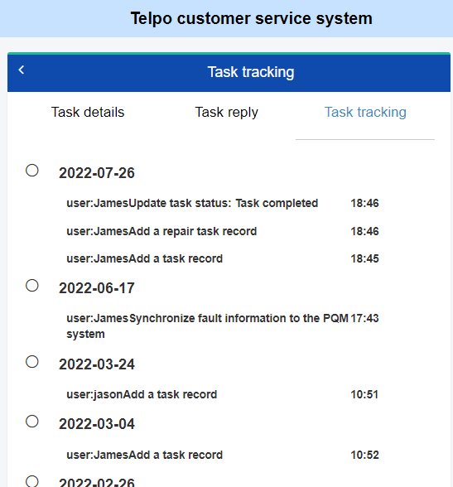

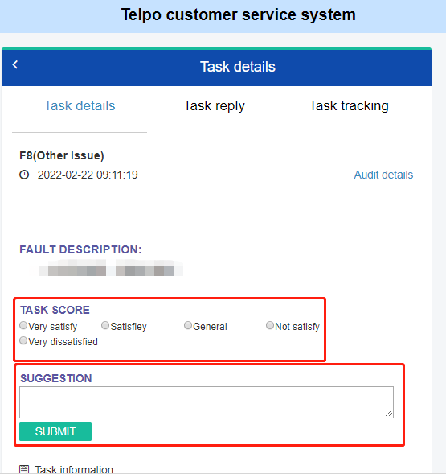

You can evaluate your satisfaction with the work order processing and make suggestions

## . FAQ download

Technical documents cover most product models, including instructions, videos, tools, SDK development kits, and demo

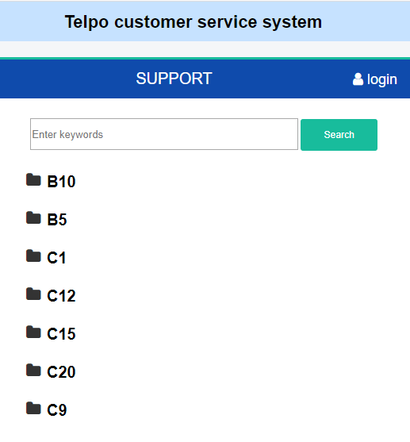

1. If you only need general technical documentation, you can simply search for the model number and find the file you want to download
2. If you need development information, maintenance information and so on, need to contact Telpo sales, and will provide your email account and preset password to us.And after registered,you can login in follow below photos

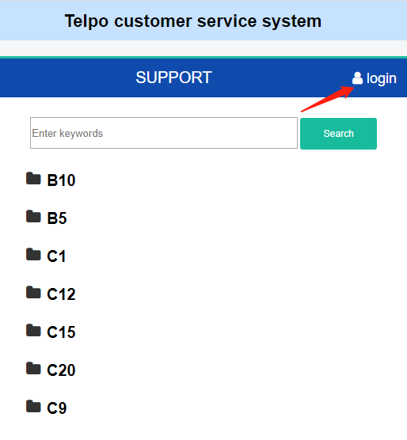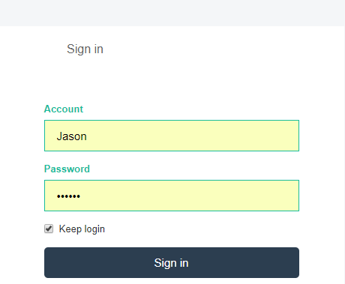

1. Support quick search, you can enter keywords to get information，Do not enter a path for search

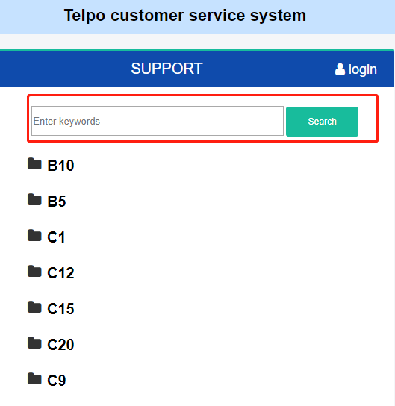

1. Quick access to SDK methods

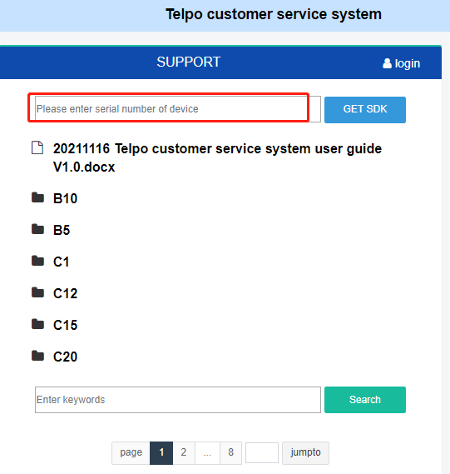

Please input your sample device’s sn and download the sdk .

If you don’t have the correct sn ,please provide your infomations to us .after confirming ,please input sn and get the sdk again in two days.

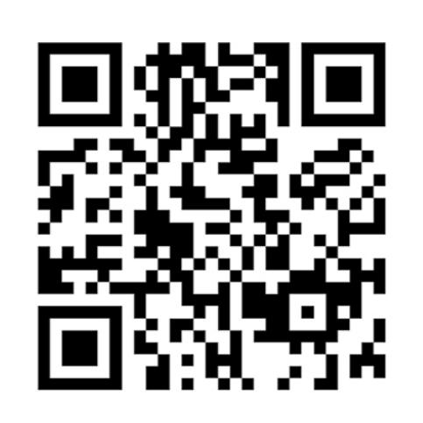

**Simple | Smart | Secure**

**Telepower Communication Co., Ltd**

**[www.telpo.com.cn](http://www.telpo.com.cn)**

**Tel： +(00)86-757-86227898**

**Email：business@telpo.com**

**Add：Foshan City, Guangdong Province, China**